Project Profile

Project Title :- School Management System Developed By :- Sidhdharajsinh & Ronak

Class :- BCA Sem – 5th

Front End :- C#

Back End :- Microsoft Access

Collage :- SSSDIIT Collage - Junagadh

Project Submit :- Bhakta Kavi Narsinh Mehta University Project Evalutor :- Mr. Brijesh Khoda sir

Academic Year:- 2019-2020

School Management System

tem

SSSDIIT



Introduction

* My project is developed using C Sharp and Microsoft Access

Tool and technology.

* My project code is totally dynamic.
* My this project is used for School Management and print the

Report of student.

* My project is computer software based and client can easily

Access this software.



Acknowledgement

It is our great pleasure to present our project report on “ School Management System ” which we conceived the 5th Semester of BCA affiliated to BKNMU , Junagadh.

I am very thankful to all, who have helped us in preparing this project. I am very happy to present this “ PROJECT REPORT ”. Before you, expecting that you will acknowledge. It is the matter of great pleasure for me. As a part of the academic study as the student of 5th semester of Bca.

I am required to undergo training for software project to the organization in order to obtain the practical knowledge and broaden our view regarding the same.

I would like to Mr. Brijesh Khoda Sir. Who has contributed the required information with special interest and guidance throghout my project work and treated me as their younger brother. I am indebted to all the people of our collage, S.S.S.D.I.I.T Computer Collage, concerned, who very helpful to me.

|  |  |  |
| --- | --- | --- |
| Index | Title | Page No |
| 1 | Requirement | 5 |
| 2 | Questionary | 5 |
| 3 | Feasibility Study | 7 |
| 4 | Hardware And Software Requirement | 9 |
| 5 | Data Dictionary | 10 |
| 6 | Data-Flow Diagram | 18 |
| 7 | Use Case Diagram | 25 |
| 8 | Pert Chart | 27 |
| 9 | Gannt Chart | 28 |
| 10 | Testing | 29 |
| 11 | Implementation And Maintenance | 31 |
| 12 | Limitations | 32 |
| 13 | Future Enhancement | 32 |
| 14 | Screen Layout of Project and Coding | 33 |

Requirement

* Admin should be login.
* Admin should be insert the Detail of new student and

Staff.

* Admin should be see the detail of student and staff.
* Admin should be Edit data of student and staff.
* Admin should be search the student and staff data by

Std, Gr no, student name and teacher name.

* Admin should be create a report of student.
* Admin should be change the Name of school into the

Setting.

* Admin should be print report of student on the printer.
* Admin should be manage the fees of student and manage

The salary of staff.

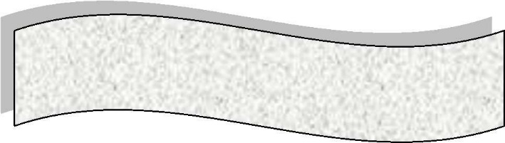

Questionary

1. What is the title of your project?

- School Management System

1. Which type of application you need?

- Software Application

1. In software your schoolname is fix?

- No

1. What is the title purpose of your software?

- The purpose of software is to manage the school

Detail with student and staff details.

* Fees details of student and staff salary should be

Managed.

1. Do you have any software currently running?

* No

1. How much time period you need for complete of your

Software?

- Within 3 Months

1. Your software will cost 12000Rs. For developing?

* Okay, Done.



Feasibility Study

Economical Feasibility



## Considering the client’s need for a school management project, the cost of Designing and Development cost around

Rs. 12000. It also covers the cost of internet access.

The costs incurred for a school management project are in keeping with the School, and are acceptable to the client.

Technical Feasibility



## Client cost for using school management software are as follows:

## Window XP(Minimum Version)

## Access Database(2007,2010,2013)

## The client can affered the cost to use the software.

Operational Feasibility



* The client have one man for managing software.

* The client is Technically, Economically and Operationally Feasible. So, this project is acceptable.



Hardware Requirement

Ram - 4GB

Hard Disk Printer



Software Requirement

Operating System Microsoft Access

Data Dictionary

* **Database Name :** 
  + - * Schoolmanagementdata
* **Tables :**

**1 - Login_Table**

|  |  |  |
| --- | --- | --- |
| Field Name | Data Type | Size |
| School_Username | Short Text | 20 |
| School_Password | Short Text | 20 |

**2 – NewStudent**

|  |  |  |
| --- | --- | --- |
| Field Name | Data Type | Size |
| Gr_No | Number | 20 |
| Student_Name | Long Text | 50 |
| Gender | Short Text | 20 |
| Father_Name | Long Text | 50 |
| Mother_Name | Long Text | 50 |
| Birth_Date | Date/Time | 20 |
| Father_Mobile_no | Long Text | 20 |
| Mother_Mobile_no | Long Text | 20 |
| Taluka | Short Text | 10 |
| District | Short Text | 20 |
| Student_Cast | Short Text | 10 |
| Pincode | Short Text | 10 |
| Regi_Address | Long Text | 50 |
| Offi_Address | Long Text | 50 |
| Admition_Std | Short Text | 10 |
| Admition_Date | Date/Time | 20 |
| Admition_Year | Short Text | 10 |
| Passout_Std | Short Text | 10 |
| Passout_Year | Short Text | 10 |
| Total_Fees | Short Text | 20 |
| Fees_Paid | Short Text | 20 |
| Receipt_No | Short Text | 20 |
| Previous_School_Name | Long Text | 50 |

**3 – School_Name**

|  |  |  |
| --- | --- | --- |
| Field Name | Data Type | Size |
| School_Name | Long Text | 50 |

**4 – Stafftable**

|  |  |  |
| --- | --- | --- |
| Field Name | Data Type | Size |
| Teacher_Id | Number | 20 |
| Tescher_Name | Long Text | 50 |
| Gender | Short Text | 10 |
| Mobile_No | Long Text | 15 |
| Email | Long Text | 50 |
| Subject | Short Text | 10 |
| Salary | Short Text | 20 |
| Address | Long Text | 50 |

Data-Flow Diagram

Symbols



|  |  |
| --- | --- |
| Symbol | Description |
|  | This Shape is used in data- flow diagram for represent a particular process. |
|  | This Shape is used in data- flow diagram for represent a input / output process. |
|  | This Shape is used in data- flow diagram for represent a condition check. |

|  |  |
| --- | --- |
|  | This Shape is used in data- flow diagram for represent a condition check. |
|  | This Shape is used in data- flow diagram for represent a flow of data |
|  | This Shape is used in data- flow diagram for represent a particular database |

0 Level Data-Flow Diagram Admin

Admin

Database

Admin

d

1st Level Data-Flow Diagram Admin

**Admin**

**Login**

**Check**

**Login**

**Ckeck**

**True**

**Dashboard**

**Fees**

**Student**

**Report**

**About Us**

**Search**

**Staff**

**Setting**

Database

2nd Level Data-Flow Diagram Admin

**Admin**

**Login**

**Check**

**Login**

**Ckeck**

**True**

**Dashboard**

**Fees**

**Student**

**Report**

**About Us**

**Search**

**Staff**

**Setting**

Imformation About Us

Report

Manage Staff

Manage Fees & Salary

Add New Student

Search Student & Staff

Manage Setting

Database



10-8-2019 25-8-2019 7-9-2019

Data Dictionary

Coding

Testing

7-7-2019

15-9-2019

13-7-2019

15-8-2019

15-9-2019

Maintenance

Designing

Feasibility Study

Implementation

Documentation

Requirements

10-9-2019

Pert Chart

Gannt Chart



|  |  |  |  |  |  |  |  |  |
| --- | --- | --- | --- | --- | --- | --- | --- | --- |
| 7-7-2019 | 13-7-2019 | 10-8-2019 | 15-8-2019 | 25-9-2019 | 7-9-2019 | 10-9-2019 | 15-9-2019 | 15-9-2019 |
| Requirements |  |  |  |  |  |  |  |  |
|  | Feasibility Study |
|  | Data Dictionary |
|  | Designing |
|  | Coding |
|  | Testing |
|  | Documentation |
|  | implementation |
|  | Maintenance |



Admin



Testing

## Testing is that step to software engineering process that could be viewed destructive rather than constructive.

In a software development project, errors can be injected at any stage during the development. Also some requirements errors and design errors can remain undetected. Ultimately, these errors will be reflected in the code.

Since the code is frequently the only product that can be executed and whose actual behavior can be observed, testing is the phase where the errors remaining form earlier phases also must be detected. Hence, testing performs a very critical role for quality assurance and for ensuring the reliability of the software.



* White Box Testing

In this system the testing is to search the undiscovered errors. White Box Testing is a test case design method that uses the control structure of the procedural

design to derive test cases. Using white box testing methods, the software developer can derive test cases.

* + Guarantee all paths will redirects the another page as the Individual working place.
  + Log in page is directed as the User name and Password both are fetch into the database and both are not same with database login table

Than display themessage and put again username and password otherwise display home page.

* Black Box Testing

Black box testing methods focus on the functional requirements of the software. That is, black box testing enables the software engineer to derive sets of input conditions that will fully exercise all functional requirements for a program.

* + Incorrect Information fills in the student entry, staff entry and functionality entry form so generated errors Massage.
  + In this system when the database structure is different from insert value than give the Error.



A software implementation method is a systematically structured approach to effectively integrate a software based service or component into workflow of an organizational structure or an individual end user.

I used parallel running to implement my software.

There is an error executing this software. In this software can not delete the data from database.

In software can delete data using datagridview in the different pages.

In this error I solve this problem and implement it.

Limitations

* In This software can not be compare Birthdate and other date between months and year.
* In this software can not apply Student Photo.

Future Enhancement

* Compare birthdate between monthly and yearly.
* Compare other date amount monthly and yearly.
* Database Backup.

Screen layout of project and Coding

**Login Page**

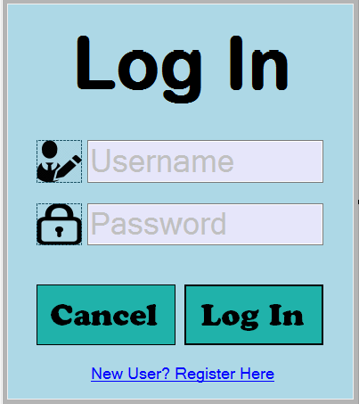

using System;

using System.Collections.Generic;

using System.ComponentModel;

using System.Data;

using System.Drawing;

using System.Linq;

using System.Text;

using System.Threading.Tasks;

using System.Windows.Forms;

using System.Data.OleDb;

namespace School_Management_Project

{

public partial class Login : Form

{

OleDbConnection con;

OleDbCommand cmd;

OleDbDataReader dr,dr1;

public Login()

{

InitializeComponent();

}

private void btncancel_Click(object sender, EventArgs e)

{

Environment.Exit(0);

}

private void btnlogin_Click(object sender, EventArgs e)

{

if (txtuser.Text == "" || txtpass.Text == "")

{

MessageBox.Show("Please Enter Value Into The Field", "Empty Field", MessageBoxButtons.OK, MessageBoxIcon.Warning);

if (txtuser.Text == "")

txtuser.Focus();

else

txtpass.Focus();

}

else if (txtuser.Text == "admin" && txtpass.Text == "admin")

{

Home h1 = new Home();

this.Hide();

h1.Show();

}

else

{

MessageBox.Show("Wrong Username And Password", "Wrong", MessageBoxButtons.OK, MessageBoxIcon.Error);

txtuser.Clear();

txtpass.Clear();

txtuser.Focus();

}

}

private void Login_Load(object sender, EventArgs e)

{

con = new OleDbConnection(@"Provider=Microsoft.ACE.OLEDB.12.0;Data Source=" + Application.StartupPath + "\\Database\\Schoolmanagementdata.accdb;Persist Security Info=False");

con.Open();

cmd = new OleDbCommand("select School_Name from SchoolName", con);

dr1 = cmd.ExecuteReader();

if (dr1.Read())

{

linkLabel1.Hide();

}

else

{

linkLabel1.Show();

}

}

private void btncancel_Click_1(object sender, EventArgs e)

{

Environment.Exit(0);

}

private void btnlogin_Click_1(object sender, EventArgs e)

{

try

{

cmd = new OleDbCommand("select * from Login_Table", con);

dr = cmd.ExecuteReader();

dr.Read();

if (txtuser.Text == "" || txtpass.Text == "")

{

MessageBox.Show("Please Enter Value Into The Field.",

"Empty Field", MessageBoxButtons.OK, MessageBoxIcon.Warning);

if (txtuser.Text == "")

txtuser.Focus();

else

txtpass.Focus();

}

else if (txtuser.Text == dr.GetValue(0).ToString() && txtpass.Text == dr.GetValue(1).ToString())

{

Home h1 = new Home();

this.Hide();

h1.Show();

}

else

{

MessageBox.Show("Wrong Username OR Password", "Wrong", MessageBoxButtons.OK, MessageBoxIcon.Error);

btnlogin.Focus();

txtuser.Text="Username";

txtuser.ForeColor = Color.Silver;

txtpass.Text = "Password";

txtpass.UseSystemPasswordChar = false;

txtpass.ForeColor = Color.Silver;

}

}

catch (Exception ex)

{

MessageBox.Show(ex.Message, "Error", MessageBoxButtons.OK,

MessageBoxIcon.Error);

}

}

private void linkLabel1_LinkClicked(object sender, LinkLabelLinkClickedEventArgs e)

{

New_Login nl = new New_Login();

this.Hide();

nl.Show();

}

private void txtuser_KeyPress(object sender, KeyPressEventArgs e)

{

}

private void txtuser_Enter(object sender, EventArgs e)

{

if (txtuser.Text == "Username")

{

txtuser.Clear();

txtuser.ForeColor = Color.Black;

}

}

private void txtuser_Leave(object sender, EventArgs e)

{

if (txtuser.Text == "")

{

txtuser.Text = "Username";

txtuser.ForeColor = Color.Silver;

}

}

private void txtpass_Enter(object sender, EventArgs e)

{

if (txtpass.Text == "Password")

{

txtpass.Clear();

txtpass.UseSystemPasswordChar = true;

txtpass.ForeColor = Color.Black;

}

}

private void txtpass_Leave(object sender, EventArgs e)

{

if (txtpass.Text == "")

{

txtpass.Text = "Password";

txtpass.UseSystemPasswordChar = false;

txtpass.ForeColor = Color.Silver;

}

}

}

}

**New_Login Page**

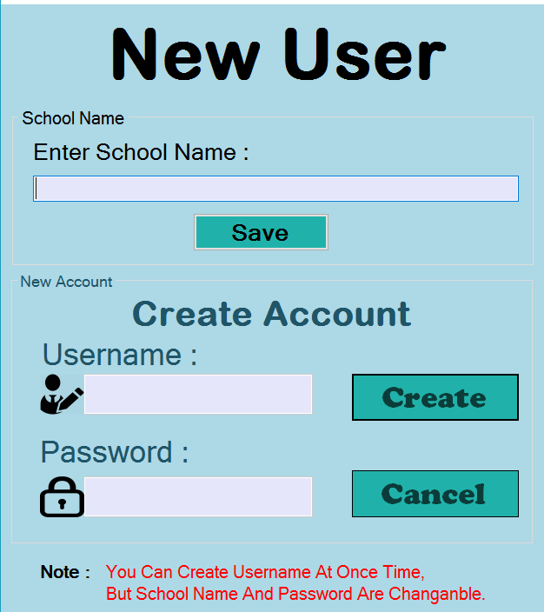

using System;

using System.Collections.Generic;

using System.ComponentModel;

using System.Data;

using System.Drawing;

using System.Linq;

using System.Text;

using System.Threading.Tasks;

using System.Windows.Forms;

using System.Data.OleDb;

namespace School_Management_Project

{

public partial class Login : Form

{

OleDbConnection con;

OleDbCommand cmd;

OleDbDataReader dr,dr1;

public Login()

{

InitializeComponent();

}

private void btncancel_Click(object sender, EventArgs e)

{

Environment.Exit(0);

}

private void btnlogin_Click(object sender, EventArgs e)

{

if (txtuser.Text == "" || txtpass.Text == "")

{

MessageBox.Show("Please Enter Value Into The Field",

"Empty Field", MessageBoxButtons.OK, MessageBoxIcon.Warning);

if (txtuser.Text == "")

txtuser.Focus();

else

txtpass.Focus();

}

else if (txtuser.Text == "admin" && txtpass.Text == "admin")

{

Home h1 = new Home();

this.Hide();

h1.Show();

}

else

{

MessageBox.Show("Wrong Username And Password",

"Wrong", MessageBoxButtons.OK, MessageBoxIcon.Error);

txtuser.Clear();

txtpass.Clear();

txtuser.Focus();

}

}

private void Login_Load(object sender, EventArgs e)

{

con = new OleDbConnection(@"Provider=Microsoft.ACE.OLEDB.12.0;Data

Source=" + Application.StartupPath + "\\Database

\\Schoolmanagementdata.accdb;Persist Security Info=False");

con.Open();

cmd = new OleDbCommand("select School_Name from SchoolName", con);

dr1 = cmd.ExecuteReader();

if (dr1.Read())

{

linkLabel1.Hide();

}

else

{

linkLabel1.Show();

}

}

private void btncancel_Click_1(object sender, EventArgs e)

{

Environment.Exit(0);

}

private void btnlogin_Click_1(object sender, EventArgs e)

{

try

{

cmd = new OleDbCommand("select * from Login_Table", con);

dr = cmd.ExecuteReader();

dr.Read();

if (txtuser.Text == "" || txtpass.Text == "")

{

MessageBox.Show("Please Enter Value Into The Field.",

"Empty Field", MessageBoxButtons.OK,

MessageBoxIcon.Warning);

if (txtuser.Text == "")

txtuser.Focus();

else

txtpass.Focus();

}

else if (txtuser.Text == dr.GetValue(0).ToString() &&

txtpass.Text == dr.GetValue(1).ToString())

{

Home h1 = new Home();

this.Hide();

h1.Show();

}

else

{

MessageBox.Show("Wrong Username OR Password",

"Wrong", MessageBoxButtons.OK, MessageBoxIcon.Error);

btnlogin.Focus();

txtuser.Text="Username";

txtuser.ForeColor = Color.Silver;

txtpass.Text = "Password";

txtpass.UseSystemPasswordChar = false;

txtpass.ForeColor = Color.Silver;

}

}

catch (Exception ex)

{

MessageBox.Show(ex.Message, "Error", MessageBoxButtons.OK,

MessageBoxIcon.Error);

}

}

private void linkLabel1_LinkClicked(object sender, LinkLabelLinkClickedEventArgs e)

{

New_Login nl = new New_Login();

this.Hide();

nl.Show();

}

private void txtuser_KeyPress(object sender, KeyPressEventArgs e)

{

}

private void txtuser_Enter(object sender, EventArgs e)

{

if (txtuser.Text == "Username")

{

txtuser.Clear();

txtuser.ForeColor = Color.Black;

}

}

private void txtuser_Leave(object sender, EventArgs e)

{

if (txtuser.Text == "")

{

txtuser.Text = "Username";

txtuser.ForeColor = Color.Silver;

}

}

private void txtpass_Enter(object sender, EventArgs e)

{

if (txtpass.Text == "Password")

{

txtpass.Clear();

txtpass.UseSystemPasswordChar = true;

txtpass.ForeColor = Color.Black;

}

}

private void txtpass_Leave(object sender, EventArgs e)

{

if (txtpass.Text == "")

{

txtpass.Text = "Password";

txtpass.UseSystemPasswordChar = false;

txtpass.ForeColor = Color.Silver;

}

}

}

}

**Home Page**

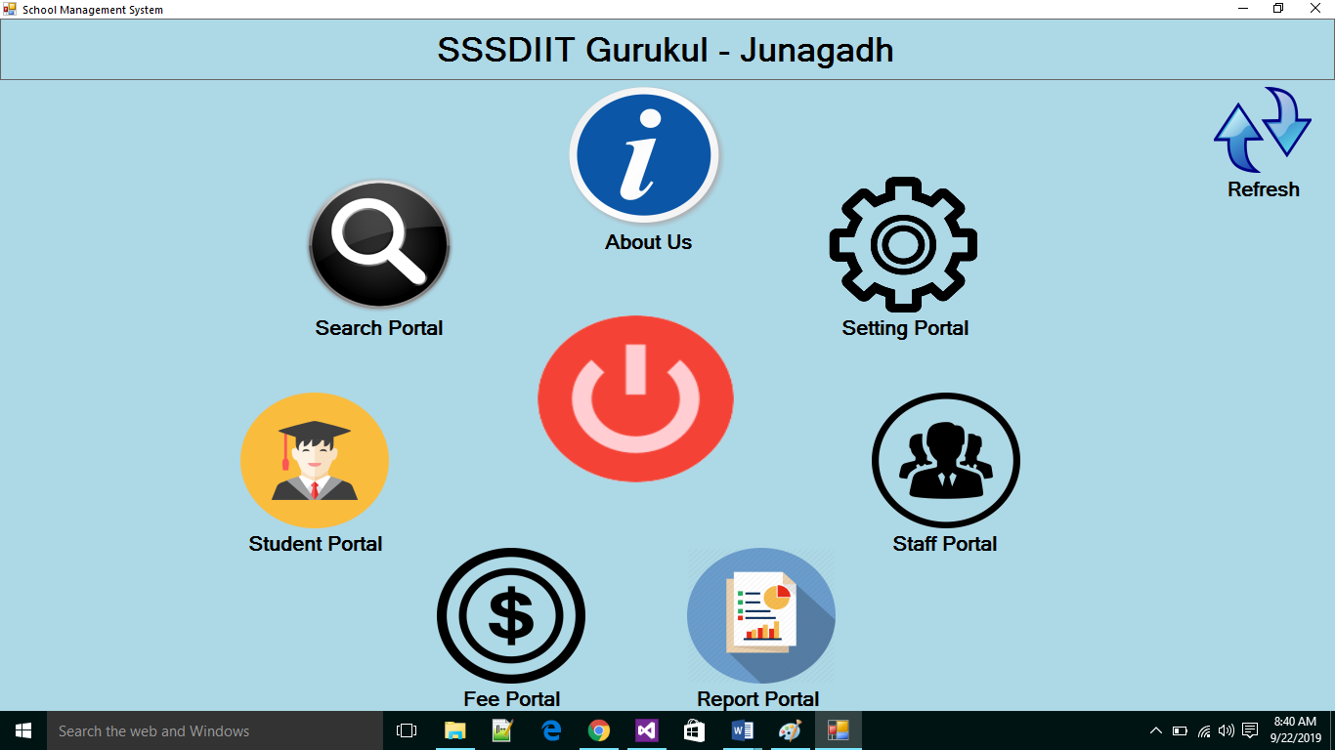

using System;

using System.Collections.Generic;

using System.ComponentModel;

using System.Data;

using System.Drawing;

using System.Linq;

using System.Text;

using System.Threading.Tasks;

using System.Windows.Forms;

using System.Data.OleDb;

namespace School_Management_Project

{

public partial class Home : Form

{

OleDbConnection con;

OleDbCommand cmd;

OleDbDataReader dr;

public Home()

{

InitializeComponent();

}

private void Home_Load(object sender, EventArgs e)

{

con = new OleDbConnection(@"Provider=Microsoft.ACE.OLEDB.12.0;Data Source=" + Application.StartupPath + "\\Database\\ Schoolmanagementdata.accdb;Persist Security Info=False");

con.Open();

cmd = new OleDbCommand("select School_Name from SchoolName", con);

dr = cmd.ExecuteReader();

if (dr.Read())

{

lbllogo.Text = dr.GetValue(0).ToString();

}

}

private void picboxlogout_Click(object sender, EventArgs e)

{

DialogResult res;

res = MessageBox.Show("Are You Want To Sure The Exit The Appliation?",

"Exit", MessageBoxButtons.YesNo, MessageBoxIcon.Question);

if (res == DialogResult.Yes)

{

Environment.Exit(0);

}

else

{

//Do Nothing

}

}

private void picboxsearch_Click(object sender, EventArgs e)

{

Searchportal sr = new Searchportal();

sr.Show();

}

private void picboxstaff_Click(object sender, EventArgs e)

{

Staffportal staffp = new Staffportal();

staffp.Show();

}

private void picboxfee_Click(object sender, EventArgs e)

{

Feeportal fp = new Feeportal();

fp.Show();

}

private void picboxstudent_Click(object sender, EventArgs e)

{

Studentportal studp = new Studentportal();

studp.Show();

}

private void picboxcourse_Click(object sender, EventArgs e)

{

About_Us aus = new About_Us();

aus.Show();

}

private void picboxclass_Click(object sender, EventArgs e)

{

Settingportal courpor = new Settingportal();

courpor.Show();

}

private void picbocreport_Click(object sender, EventArgs e)

{

Reportportal rp = new Reportportal();

rp.Show();

}

private void pictureBox1_Click(object sender, EventArgs e)

{

Home h1 = new Home();

this.Close();

h1.Show();

}

}

}

**Search Portal**

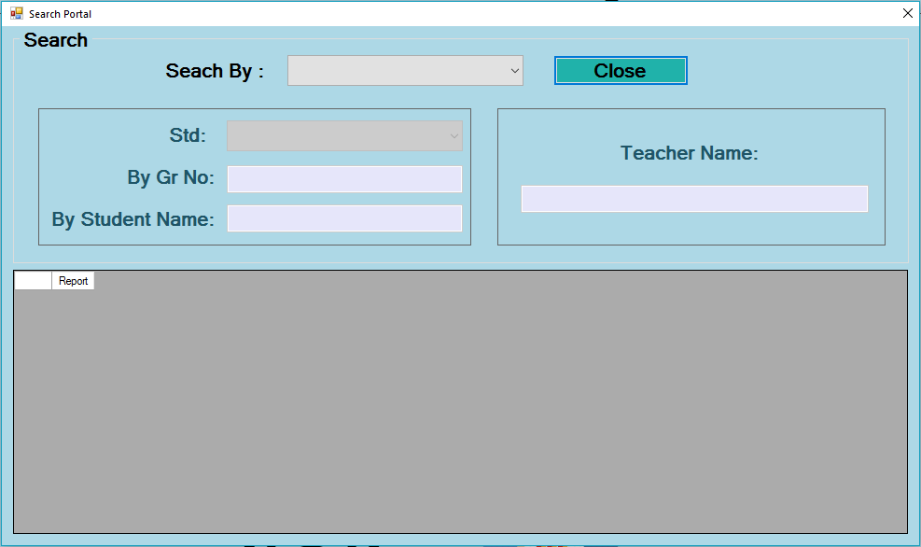

using System;

using System.Collections.Generic;

using System.ComponentModel;

using System.Data;

using System.Drawing;

using System.Linq;

using System.Text;

using System.Threading.Tasks;

using System.Windows.Forms;

using System.Data.OleDb;

namespace School_Management_Project

{

public partial class Searchportal : Form

{

OleDbConnection con;

OleDbCommand cmd;

OleDbDataReader dr,dr1;

DataTable dt;

public Searchportal()

{

InitializeComponent();

}

private void Searchportal_Load(object sender, EventArgs e)

{

con = new OleDbConnection(@"Provider=Microsoft.ACE.OLEDB.12.0;Data Source=" + Application.StartupPath + "\\Database\\Schoolmanagementdata.accdb;Persist Security Info=False");

con.Open();

panel1.Enabled = false;

panel2.Enabled = false;

}

private void button1_Click(object sender, EventArgs e)

{

this.Hide();

}

private void txtgrno_TextChanged(object sender, EventArgs e)

{

if (txtgrno.Text == "")

{

display_student();

}

else

{

cmd = new OleDbCommand("select * from NewStudent where Gr_No like '" + txtgrno.Text + "'", con);

dr = cmd.ExecuteReader();

dt = new DataTable();

dt.Load(dr);

dtgwsearchportal.DataSource = dt;

}

}

private void comboBox1_SelectedIndexChanged(object sender, EventArgs e)

{

if (comboBox1.SelectedIndex == 0)

{

panel1.Enabled = true;

panel2.Enabled = false;

display_student();

}

else

{

panel1.Enabled = false;

panel2.Enabled = true;

display_teacher();

}

}

public void display_student()

{

cmd = new OleDbCommand("select * from NewStudent", con);

dr = cmd.ExecuteReader();

dt = new DataTable();

dt.Load(dr);

dtgwsearchportal.DataSource = dt;

}

public void display_teacher()

{

cmd = new OleDbCommand("select * from Stafftable", con);

dr1 = cmd.ExecuteReader();

dt = new DataTable();

dt.Load(dr1);

dtgwsearchportal.DataSource = dt;

}

private void textBox1_TextChanged(object sender, EventArgs e)

{

cmd = new OleDbCommand("select * from Stafftable where Teacher_Name like '" + textBox1.Text + "%'", con);

dr1 = cmd.ExecuteReader();

dt = new DataTable();

dt.Load(dr1);

dtgwsearchportal.DataSource = dt;

}

private void cmbstd_SelectedIndexChanged(object sender, EventArgs e)

{

try

{

cmd = new OleDbCommand("select * from NewStudent where Admition_Std

like '" + cmbstd.Text + "%'", con);

dr = cmd.ExecuteReader();

dt = new DataTable();

dt.Load(dr);

dtgwsearchportal.DataSource = dt;

}

catch (Exception ex)

{

MessageBox.Show(ex.Message, "Error", MessageBoxButtons.OK,MessageBoxIcon.Error);

}

}

private void txtstudname_TextChanged(object sender, EventArgs e)

{

cmd = new OleDbCommand("select * from NewStudent where Student_Name

like '" + txtstudname.Text + "%'", con);

dr = cmd.ExecuteReader();

dt = new DataTable();

dt.Load(dr);

dtgwsearchportal.DataSource = dt;

}

}

}

**Student Portal**

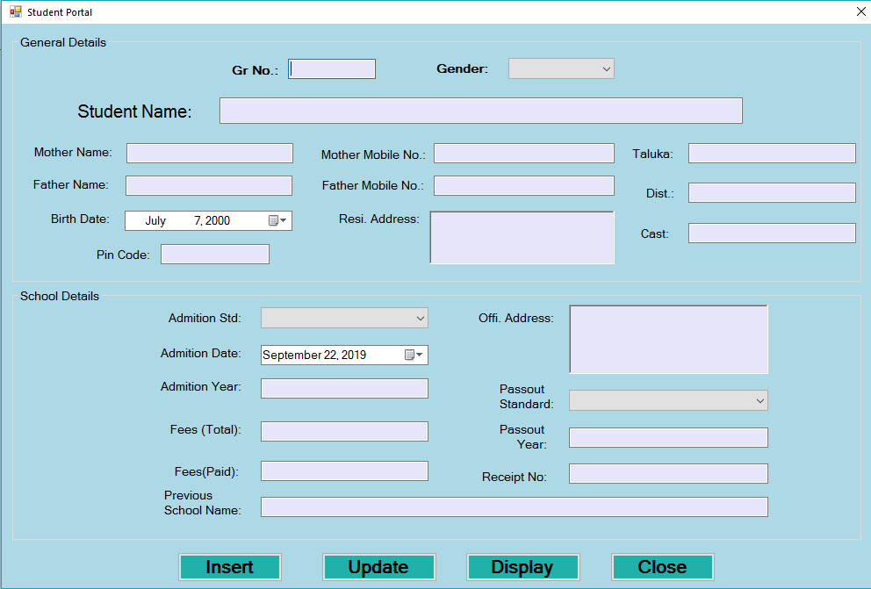

using System;

using System.Collections.Generic;

using System.ComponentModel;

using System.Data;

using System.Drawing;

using System.Linq;

using System.Text;

using System.Threading.Tasks;

using System.Windows.Forms;

using System.Data.OleDb;

using System.Drawing.Printing;

namespace School_Management_Project

{

public partial class Studentportal : Form

{

OleDbConnection con;

OleDbCommand cmd;

public Studentportal()

{

InitializeComponent();

}

private void btnback_Click(object sender, EventArgs e)

{

this.Close();

}

private void button6_Click(object sender, EventArgs e)

{

Display_Student ds = new Display_Student();

this.Hide();

ds.Show();

}

private void Studentportal_Load(object sender, EventArgs e)

{

con = new OleDbConnection(@"Provider=Microsoft.ACE.OLEDB.12.0;Data Source=" + Application.StartupPath + "\\Database\\Schoolmanagementdata.accdb;Persist Security Info=False");

con.Open();

}

private void button5_Click(object sender, EventArgs e)

{

}

private void button2_Click(object sender, EventArgs e)

{

try

{

if (textBox1.Text == "" || comboBox1.Text == "" || textBox2.Text == "" || textBox5.Text == "" || textBox17.Text == "" || txtpincode.Text == "" || textBox15.Text == "" || textBox16.Text == "" || richtxtaddress.Text == "" || textBox7.Text == "" || textBox8.Text == "" || txtcast.Text == "" || cmbadmitionstd.Text == "" || textBox13.Text == "" || richTextBox1.Text == "" || comboBox2.Text == "" || textBox12.Text == "" || textBox10.Text == "" || textBox18.Text == "" || textBox19.Text == "" || textBox9.Text == "")

{

MessageBox.Show("Please Enter Value Into The Field", "Blank Value", MessageBoxButtons.OK, MessageBoxIcon.Warning);

}

else

{

cmd = new OleDbCommand("insert into NewStudent values('" + textBox1.Text + "','" + textBox2.Text + "','" + comboBox1.Text + "','" + textBox17.Text + "','" + textBox5.Text + "','" + dateTimePicker1.Text + "','" + textBox16.Text + "','" + textBox15.Text + "','" + textBox7.Text + "','" + textBox8.Text + "','" + txtcast.Text + "','" + txtpincode.Text + "','" + richtxtaddress.Text + "','" + richTextBox1.Text + "','" + cmbadmitionstd.Text + "','" + dateTimePicker2.Text + "','" + textBox13.Text + "','" + comboBox2.Text + "','" + textBox12.Text + "','" + textBox10.Text + "','" + textBox18.Text + "','" + textBox19.Text + "', '" + textBox9.Text + "')", con);

cmd.ExecuteNonQuery();

MessageBox.Show("Record Inserted Successfully.");

textBox1.Clear();

comboBox1.SelectedIndex=-1;

textBox2.Clear();

textBox5.Clear();

textBox17.Clear();

txtpincode.Clear();

textBox15.Clear();

textBox16.Clear();

richtxtaddress.Clear();

textBox7.Clear();

textBox8.Clear();

txtcast.Clear();

cmbadmitionstd.SelectedIndex=-1;

textBox13.Clear();

richTextBox1.Clear();

comboBox2.SelectedIndex=-1;

textBox12.Clear();

textBox10.Clear();

textBox18.Clear();

textBox19.Clear();

textBox9.Clear();

}

}

catch (Exception ex)

{

MessageBox.Show(ex.Message);

}

}

private void textBox15_KeyPress(object sender, KeyPressEventArgs e)

{

char ch = e.KeyChar;

if(!Char.IsDigit(ch) && ch != 8 && ch != 46)

{

e.Handled=true;

}

}

private void textBox16_KeyPress(object sender, KeyPressEventArgs e)

{

char ch = e.KeyChar;

if (!Char.IsDigit(ch) && ch != 8 && ch != 46)

{

e.Handled = true;

}

}

private void txtpincode_KeyPress(object sender, KeyPressEventArgs e)

{

char ch = e.KeyChar;

if (!Char.IsDigit(ch) && ch != 8 && ch != 46)

{

e.Handled = true;

}

}

private void textBox1_KeyPress(object sender, KeyPressEventArgs e)

{

char ch = e.KeyChar;

if (!Char.IsDigit(ch) && ch != 8 && ch != 46)

{

e.Handled = true;

}

}

private void textBox14_KeyPress(object sender, KeyPressEventArgs e)

{

char ch = e.KeyChar;

if (!Char.IsDigit(ch) && ch != 8 && ch != 46)

{

e.Handled = true;

}

}

private void textBox13_KeyPress_1(object sender, KeyPressEventArgs e)

{

char ch = e.KeyChar;

if (!Char.IsDigit(ch) && ch != 8 && ch != 46)

{

e.Handled = true;

}

}

private void button3_Click(object sender, EventArgs e)

{

Student_Update su = new Student_Update();

this.Hide();

su.Show();

}

}

}

**Student_Update**

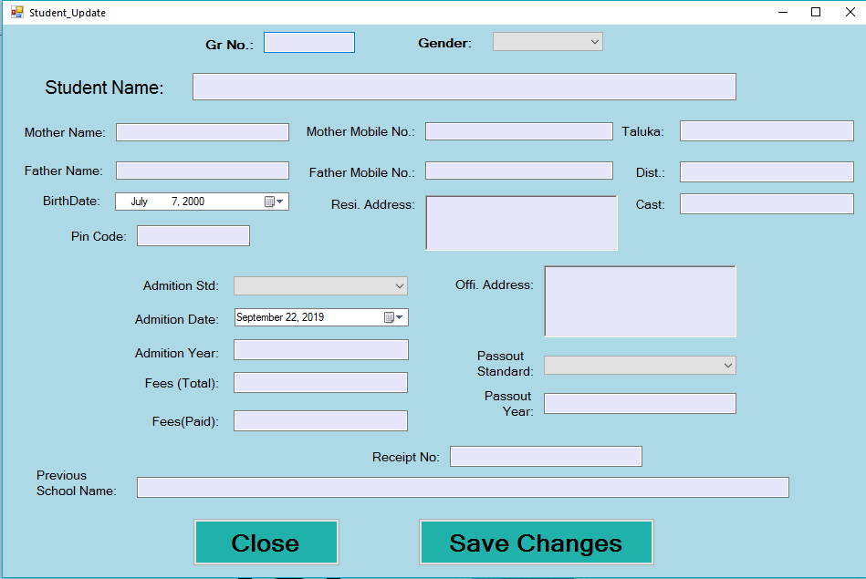

using System;

using System.Collections.Generic;

using System.ComponentModel;

using System.Data;

using System.Drawing;

using System.Linq;

using System.Text;

using System.Threading.Tasks;

using System.Windows.Forms;

using System.Data.OleDb;

namespace School_Management_Project

{

public partial class Student_Update : Form

{

OleDbConnection con;

OleDbCommand cmd;

OleDbDataReader dr;

public Student_Update()

{

InitializeComponent();

}

private void Student_Update_Load(object sender, EventArgs e)

{

con = new OleDbConnection(@"Provider=Microsoft.ACE.OLEDB.12.0;Data Source=" + Application.StartupPath + "\\Database\\Schoolmanagementdata.accdb;Persist Security Info=False");

con.Open();

textBox1.Focus();

}

private void button2_Click(object sender, EventArgs e)

{

this.Hide();

}

private void textBox1_TextChanged(object sender, EventArgs e)

{

try

{

cmd = new OleDbCommand("select * from NewStudent where Gr_No like

'" + textBox1.Text + "'", con);

dr = cmd.ExecuteReader();

if (textBox1.Text == "")

{

comboBox1.SelectedIndex = -1;

textBox2.Clear();

textBox5.Clear();

textBox17.Clear();

textBox15.Clear();

textBox16.Clear();

richtxtaddress.Clear();

txtpincode.Clear();

richTextBox1.Clear();

textBox7.Clear();

textBox8.Clear();

textBox3.Clear();

cmbadmitionstd.SelectedIndex = -1;

textBox13.Clear();

richTextBox1.Clear();

comboBox2.SelectedIndex = -1;

textBox12.Clear();

textBox10.Clear();

textBox18.Clear();

textBox19.Clear();

textBox9.Clear();

}

else if (dr.Read())

{

comboBox1.Text = dr.GetValue(2).ToString();

textBox2.Text = dr.GetValue(1).ToString();

textBox5.Text = dr.GetValue(4).ToString();

textBox17.Text = dr.GetValue(3).ToString();

dateTimePicker1.Text = dr.GetValue(5).ToString();

textBox15.Text = dr.GetValue(7).ToString();

textBox16.Text = dr.GetValue(6).ToString();

txtpincode.Text = dr.GetValue(11).ToString();

richtxtaddress.Text = dr.GetValue(12).ToString();

textBox7.Text = dr.GetValue(8).ToString();

textBox8.Text = dr.GetValue(9).ToString();

textBox3.Text = dr.GetValue(10).ToString();

cmbadmitionstd.Text = dr.GetValue(14).ToString();

dateTimePicker2.Text = dr.GetValue(15).ToString();

textBox13.Text = dr.GetValue(16).ToString();

richTextBox1.Text = dr.GetValue(13).ToString();

comboBox2.Text = dr.GetValue(17).ToString();

textBox12.Text = dr.GetValue(18).ToString();

textBox10.Text = dr.GetValue(19).ToString();

textBox18.Text = dr.GetValue(20).ToString();

textBox19.Text = dr.GetValue(21).ToString();

textBox9.Text = dr.GetValue(22).ToString();

}

else

{

comboBox1.SelectedIndex = -1;

textBox2.Clear();

textBox5.Clear();

textBox17.Clear();

textBox15.Clear();

textBox16.Clear();

txtpincode.Clear();

richtxtaddress.Clear();

richTextBox1.Clear();

textBox7.Clear();

textBox8.Clear();

textBox3.Clear();

cmbadmitionstd.SelectedIndex = -1;

textBox13.Clear();

richTextBox1.Clear();

comboBox2.SelectedIndex = -1;

textBox12.Clear();

textBox10.Clear();

textBox18.Clear();

textBox19.Clear();

textBox9.Clear();

}

}

catch (Exception ex)

{

MessageBox.Show(ex.Message, "Error", MessageBoxButtons.OK, MessageBoxIcon.Error);

}

}

private void button2_Click_1(object sender, EventArgs e)

{

this.Hide();

}

private void button3_Click(object sender, EventArgs e)

{

try

{

if (textBox1.Text == "")

{

MessageBox.Show("Plese Enter Student Gr Number", "Blank Value", MessageBoxButtons.OK, MessageBoxIcon.Warning);

textBox2.Focus();

}

else

{

cmd = new OleDbCommand("update NewStudent set Student_Name='" + textBox2.Text + "',Gender='" + comboBox1.Text + "',Father_Name='" + textBox17.Text + "',Mother_Name='" + textBox5.Text + "',Birth_Date='" + dateTimePicker1.Text + "',Father_Mobile_No='" + textBox16.Text + "',Mother_Mobile_No='" + textBox15.Text + "',Taluka='" + textBox7.Text + "',District='" + textBox8.Text + "',Pincode='" + txtpincode.Text + "',Regi_Address='" + richtxtaddress.Text + "',Offi_Address='" + richTextBox1.Text + "',Admition_Std='" + cmbadmitionstd.Text + "',Admition_Date='" + dateTimePicker2.Text + "',Admition_Year='" + textBox13.Text + "',Passout_Std='" + comboBox2.Text + "',Passout_Year='" + textBox12.Text + "',Total_Fees='" + textBox10.Text + "',Fees_Paid='" + textBox18.Text + "',Receipt_No='" + textBox19.Text + "',Previous_School_Name='" + textBox9.Text + "',Student_Cast='" + textBox3.Text + "' where Gr_No=" + textBox1.Text + "", con);

int res = cmd.ExecuteNonQuery();

if (res > 0)

{

MessageBox.Show("Record Update Successfully", "Done",

MessageBoxButtons.OK, MessageBoxIcon.Information);

textBox1.Clear();

textBox1.Focus();

}

else

{

MessageBox.Show("Something Went Wrong", "Error", MessageBoxButtons.OK, MessageBoxIcon.Error);

}

}

}

catch (Exception ex)

{

MessageBox.Show(ex.Message, "Error", MessageBoxButtons.OK, MessageBoxIcon.Error);

}

}

}

}

**Display Student**

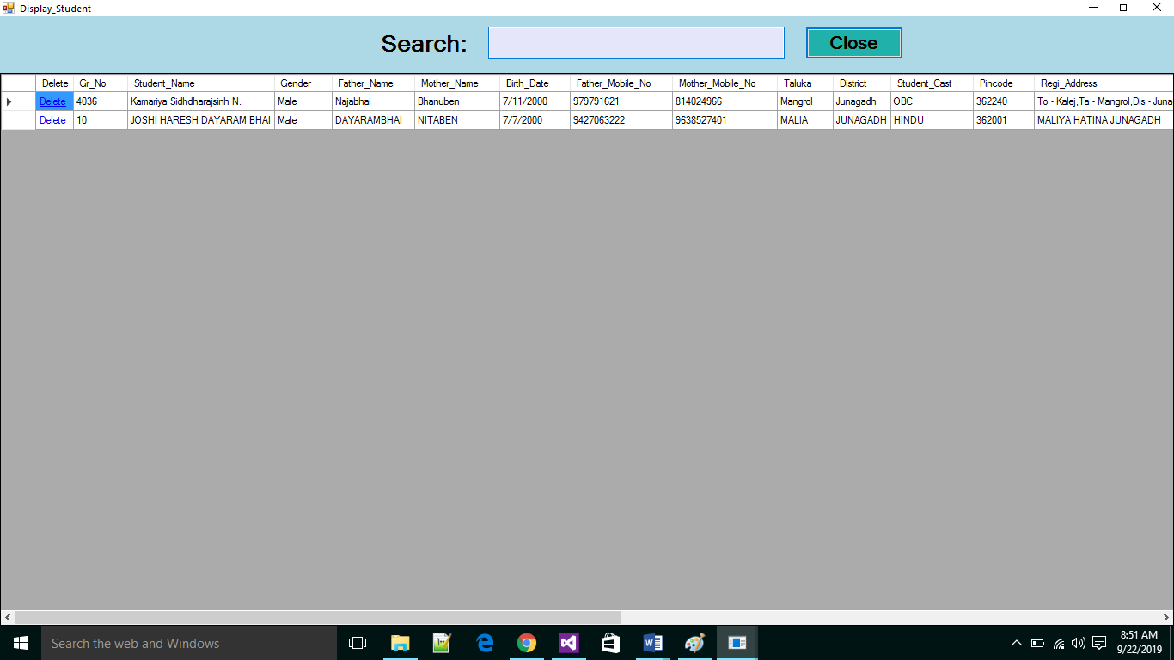

using System;

using System.Collections.Generic;

using System.ComponentModel;

using System.Data;

using System.Drawing;

using System.Linq;

using System.Text;

using System.Threading.Tasks;

using System.Windows.Forms;

using System.Data.OleDb;

namespace School_Management_Project

{

public partial class Display_Student : Form

{

OleDbConnection con;

OleDbCommand cmd;

OleDbDataReader dr;

DataTable dt;

public Display_Student()

{

InitializeComponent();

}

public void display()

{

cmd = new OleDbCommand("select * from NewStudent", con);

dr = cmd.ExecuteReader();

dt = new DataTable();

dt.Load(dr);

dataGridView1.DataSource = dt;

}

private void dataGridView1_CellContentClick(object sender, DataGridViewCellEventArgs e)

{

int id = Convert.ToInt16(dataGridView1.Rows[e.RowIndex].Cells[1].FormattedValue.ToString());

if (e.ColumnIndex == 0)

{

cmd = new OleDbCommand("delete from NewStudent where Gr_No=" + id +

"", con);

cmd.ExecuteNonQuery();

display();

}

}

private void Display_Student_Load(object sender, EventArgs e)

{

con = new OleDbConnection(@"Provider=Microsoft.ACE.OLEDB.12.0;Data Source=" + Application.StartupPath + "\\Database\\Schoolmanagementdata.accdb;Persist Security Info=False");

con.Open();

display();

}

private void textBox1_TextChanged(object sender, EventArgs e)

{

cmd = new OleDbCommand("select * from NewStudent where Student_Name like '" + textBox1.Text + "%'", con);

dr = cmd.ExecuteReader();

dt = new DataTable();

dt.Load(dr);

dataGridView1.DataSource = dt;

}

private void button1_Click(object sender, EventArgs e)

{

this.Hide();

}

}

}

**Fees Portal**

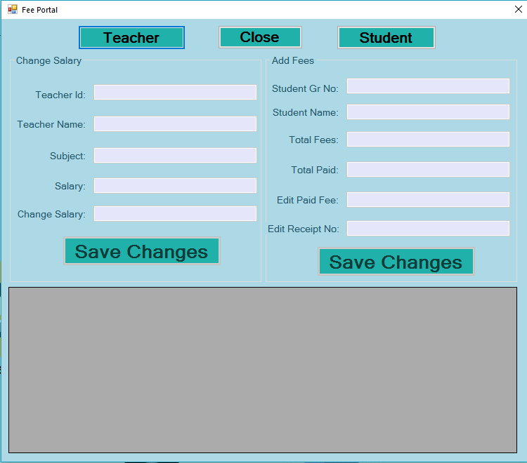

using System;

using System.Collections.Generic;

using System.ComponentModel;

using System.Data;

using System.Drawing;

using System.Linq;

using System.Text;

using System.Threading.Tasks;

using System.Windows.Forms;

using System.Data.OleDb;

namespace School_Management_Project

{

public partial class Feeportal : Form

{

OleDbConnection con;

OleDbCommand cmd;

OleDbDataReader dr,dr1;

DataTable dt;

public Feeportal()

{

InitializeComponent();

}

private void btnback_Click(object sender, EventArgs e)

{

this.Hide();

}

private void Feeportal_Load(object sender, EventArgs e)

{

con = new OleDbConnection(@"Provider=Microsoft.ACE.OLEDB.12.0;Data Source=" + Application.StartupPath + "\\Database\\Schoolmanagementdata.accdb;Persist Security Info=False");

con.Open();

groupBox1.Enabled = false;

groupBox2.Enabled = false;

textBox3.Enabled = false;

textBox7.Enabled = false;

textBox5.Enabled = false;

textBox1.Enabled = false;

textBox9.Enabled = false;

textBox2.Enabled = false;

}

private void button3_Click(object sender, EventArgs e)

{

groupBox1.Enabled = true;

groupBox2.Enabled = false;

textBox10.Focus();

try

{

cmd = new OleDbCommand("select Teacher_Id,Teacher_Name,Subject,Salary from Stafftable", con);

dr1 = cmd.ExecuteReader();

dt = new DataTable();

dt.Load(dr1);

dtgwsearchportal.DataSource = dt;

}

catch (Exception ex)

{

MessageBox.Show(ex.Message, "Error", MessageBoxButtons.OK, MessageBoxIcon.Error);

}

}

private void button4_Click(object sender, EventArgs e)

{

groupBox2.Enabled = true;

groupBox1.Enabled = false;

textBox4.Focus();

try

{

cmd = new OleDbCommand("select Student_Name,Gr_No,Gender,Admition_Std,Total_Fees,Fees_Paid,Receipt_No

from NewStudent", con);

dr = cmd.ExecuteReader();

dt = new DataTable();

dt.Load(dr);

dtgwsearchportal.DataSource = dt;

textBox10.Focus();

}

catch (Exception ex)

{

MessageBox.Show(ex.Message, "Error", MessageBoxButtons.OK, MessageBoxIcon.Error);

}

}

private void textBox4_TextChanged(object sender, EventArgs e)

{

try

{

cmd = new OleDbCommand("select Student_Name,Gr_No,Gender,Admition_Std,Total_Fees,Fees_Paid,Receipt_No from NewStudent where Gr_No like'" + textBox4.Text + "'", con);

dr = cmd.ExecuteReader();

if (textBox4.Text == "")

{

textBox3.Clear();

textBox7.Clear();

textBox5.Clear();

textBox6.Clear();

textBox8.Clear();

}

else if (dr.Read())

{

textBox3.Text = dr.GetValue(0).ToString();

textBox7.Text = dr.GetValue(4).ToString();

textBox5.Text = dr.GetValue(5).ToString();

textBox6.Text = dr.GetValue(5).ToString();

textBox8.Text = dr.GetValue(6).ToString();

}

else

{

textBox3.Clear();

textBox7.Clear();

textBox5.Clear();

textBox6.Clear();

textBox8.Clear();

}

}

catch (Exception ex)

{

MessageBox.Show(ex.Message, "Error", MessageBoxButtons.OK, MessageBoxIcon.Error);

}

}

private void button2_Click(object sender, EventArgs e)

{

try

{

if (textBox4.Text == "")

{

MessageBox.Show("Please Enter Student Gr Number", "Blank Value", MessageBoxButtons.OK, MessageBoxIcon.Warning);

textBox4.Focus();

}

else

{

cmd = new OleDbCommand("update NewStudent set Fees_Paid='" + textBox6.Text + "',Receipt_No='" + textBox8.Text + "' where Gr_No=" + textBox4.Text + "", con);

int res = cmd.ExecuteNonQuery();

if (res > 0)

{

MessageBox.Show("Fee And Receipt No Changed Successfully", "Done", MessageBoxButtons.OK, MessageBoxIcon.Information);

cmd = new OleDbCommand("select Student_Name,Gr_No,Gender,Admition_Std,Total_Fees,Fees_Paid,Receipt_No from NewStudent where Gr_No like'" + textBox4.Text + "'", con);

dr = cmd.ExecuteReader();

dt = new DataTable();

dt.Load(dr);

dtgwsearchportal.DataSource = dt;

textBox4.Clear();

textBox4.Focus();

}

else

{

MessageBox.Show("Something Went Wrong", "Error", MessageBoxButtons.OK, MessageBoxIcon.Error);

}

}

}

catch (Exception ex)

{

MessageBox.Show(ex.Message, "Error", MessageBoxButtons.OK, MessageBoxIcon.Error);

}

}

private void textBox10_TextChanged(object sender, EventArgs e)

{

try

{

cmd = new OleDbCommand("select Teacher_Id,Teacher_Name,Subject,Salary from Stafftable where Teacher_Id like'" + textBox10.Text + "'", con);

dr = cmd.ExecuteReader();

if (textBox10.Text == "")

{

textBox1.Clear();

textBox9.Clear();

textBox2.Clear();

textBox11.Clear();

}

else if (dr.Read())

{

textBox1.Text = dr.GetValue(1).ToString();

textBox9.Text = dr.GetValue(2).ToString();

textBox2.Text = dr.GetValue(3).ToString();

textBox11.Text = dr.GetValue(3).ToString();

}

else

{

textBox1.Clear();

textBox9.Clear();

textBox2.Clear();

textBox11.Clear();

}

}

catch (Exception ex)

{

MessageBox.Show(ex.Message, "Error", MessageBoxButtons.OK, MessageBoxIcon.Error);

}

}

private void button1_Click(object sender, EventArgs e)

{

try

{

if (textBox10.Text == "")

{

MessageBox.Show("Please Enter Teacher Id.", "Blank Value", MessageBoxButtons.OK, MessageBoxIcon.Warning);

textBox10.Focus();

}

else

{

cmd = new OleDbCommand("update Stafftable set Salary='" + textBox11.Text + "' where Teacher_Id=" + textBox10.Text + "", con);

int res = cmd.ExecuteNonQuery();

if (res > 0)

{

MessageBox.Show("Salary Changed Successfully", "Done", MessageBoxButtons.OK, MessageBoxIcon.Information);

cmd = new OleDbCommand("select Teacher_Id,Teacher_Name,Subject,Salary from Stafftable where Teacher_Id like '" + textBox10.Text + "'", con);

dr1 = cmd.ExecuteReader();

dt = new DataTable();

dt.Load(dr1);

dtgwsearchportal.DataSource = dt;

textBox10.Clear();

textBox10.Focus();

}

else

{

MessageBox.Show("Something Went Wrong", "Error", MessageBoxButtons.OK, MessageBoxIcon.Error);

}

}

}

catch (Exception ex)

{

MessageBox.Show(ex.Message, "Error", MessageBoxButtons.OK, MessageBoxIcon.Error);

}

}

}

}

**Report Portal**

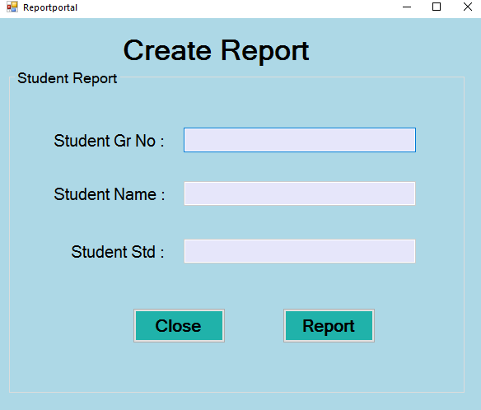

using System;

using System.Collections.Generic;

using System.ComponentModel;

using System.Data;

using System.Drawing;

using System.Linq;

using System.Text;

using System.Threading.Tasks;

using System.Windows.Forms;

using System.Data.OleDb;

namespace School_Management_Project

{

public partial class Reportportal : Form

{

OleDbConnection con;

OleDbCommand cmd;

OleDbDataReader dr,dr1;

public Reportportal()

{

InitializeComponent();

}

private void Reportportal_Load(object sender, EventArgs e)

{

con = new OleDbConnection(@"Provider=Microsoft.ACE.OLEDB.12.0;Data Source=" + Application.StartupPath + "\\Database\\Schoolmanagementdata.accdb;Persist Security Info=False");

con.Open();

textBox2.Enabled = false;

textBox3.Enabled = false;

}

private void textBox1_TextChanged(object sender, EventArgs e)

{

if (textBox1.Text == "")

{

textBox2.Clear();

textBox3.Clear();

}

else

{

cmd = new OleDbCommand("select Student_Name,Admition_Std from

NewStudent where Gr_No like '" + textBox1.Text + "'", con);

dr = cmd.ExecuteReader();

if (dr.Read())

{

textBox2.Text = dr.GetValue(0).ToString();

textBox3.Text = dr.GetValue(1).ToString();

}

else

{

textBox2.Clear();

textBox3.Clear();

}

}

}

private void button4_Click(object sender, EventArgs e)

{

if (textBox1.Text == "")

{

MessageBox.Show("Please Enter Student GR NO", "Blank Value", MessageBoxButtons.OK, MessageBoxIcon.Warning);

textBox1.Focus();

}

else

{

Report_Class.StudentNo = int.Parse(textBox1.Text);

Student_Report sr = new Student_Report();

this.Hide();

sr.Show();

}

}

private void button1_Click(object sender, EventArgs e)

{

this.Hide();

}

}

}

**Report**

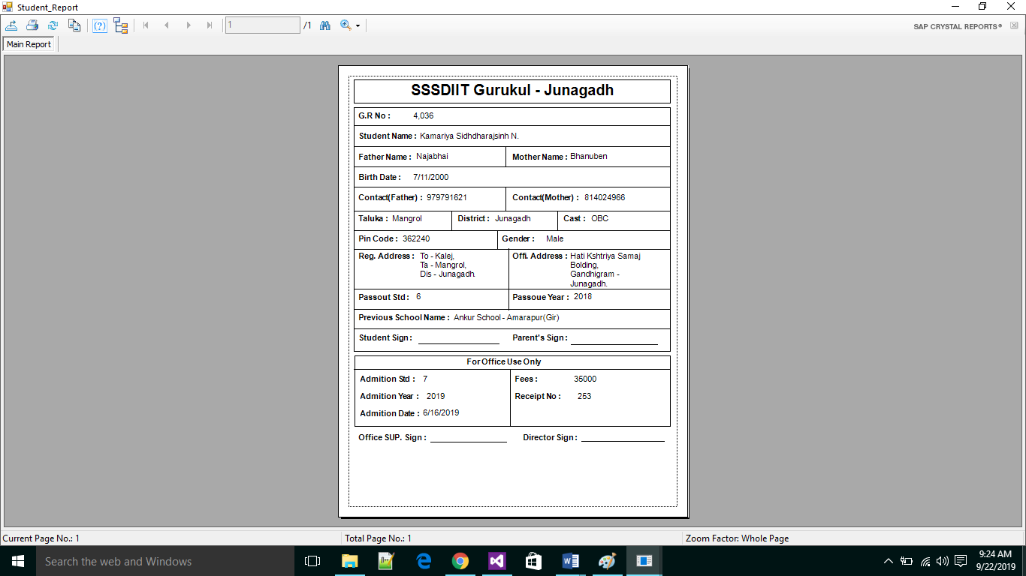

**Staff Portal**

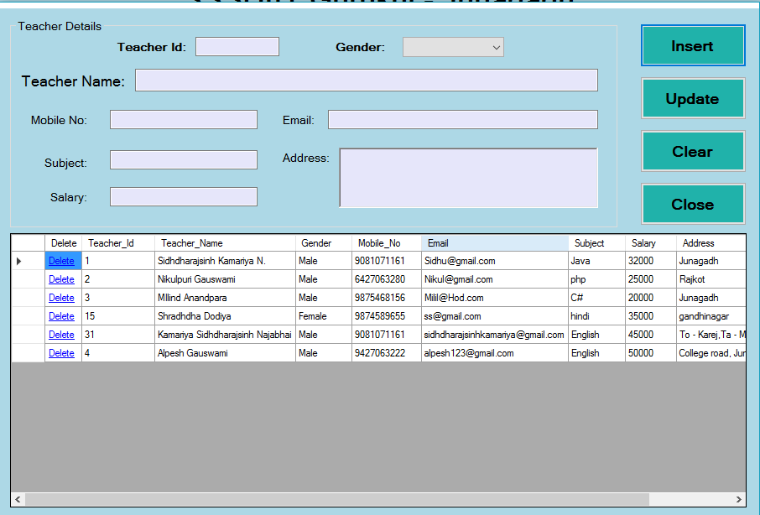

using System;

using System.Collections.Generic;

using System.ComponentModel;

using System.Data;

using System.Drawing;

using System.Linq;

using System.Text;

using System.Threading.Tasks;

using System.Windows.Forms;

using System.Data.OleDb;

namespace School_Management_Project

{

public partial class Staffportal : Form

{

OleDbConnection con;

OleDbCommand cmd;

OleDbDataReader dr;

DataTable dt;

public Staffportal()

{

InitializeComponent();

}

public void display()

{

cmd = new OleDbCommand("select * from Stafftable", con);

dr = cmd.ExecuteReader();

dt = new DataTable();

dt.Load(dr);

dataGridView1.DataSource = dt;

}

private void btnback_Click(object sender, EventArgs e)

{

Home h1 = new Home();

this.Hide();

h1.Show();

}

private void button5_Click(object sender, EventArgs e)

{

this.Hide();

}

private void dataGridView1_CellContentClick(object sender, DataGridViewCellEventArgs e)

{

int id = Convert.ToInt16(dataGridView1.Rows[e.RowIndex].Cells[1].FormattedValue.ToString());

if (e.ColumnIndex == 0)

{

cmd = new OleDbCommand("delete from Stafftable where Teacher_Id=" + id + "", con);

cmd.ExecuteNonQuery();

display();

}

}

private void Staffportal_Load(object sender, EventArgs e)

{

con = new OleDbConnection(@"Provider=Microsoft.ACE.OLEDB.12.0;Data Source=" + Application.StartupPath + "\\Database\\Schoolmanagementdata.accdb;Persist Security Info=False");

con.Open();

display();

}

private void button1_Click(object sender, EventArgs e)

{

try

{

if (comboBox1.SelectedIndex == -1 || textBox1.Text == "" || textBox5.Text == "" || textBox15.Text == "" || textBox17.Text == "" || textBox6.Text == "" || richtxtaddress.Text == "")

{

MessageBox.Show("Please Enter Value Into The Field", "Blank Value", MessageBoxButtons.OK, MessageBoxIcon.Warning);

}

else

{

cmd = new OleDbCommand("insert into Stafftable values('" + textBox2.Text + "','" + textBox1.Text + "','" + comboBox1.Text + "','" + textBox5.Text + "','" + textBox15.Text + "','" + textBox17.Text + "','" + textBox6.Text + "','" + richtxtaddress.Text + "')", con);

cmd.ExecuteNonQuery();

MessageBox.Show("Record Inserted Successfully.");

display();

comboBox1.SelectedIndex = -1;

textBox1.Clear();

textBox2.Clear();

textBox5.Clear();

textBox15.Clear();

textBox17.Clear();

textBox6.Clear();

richtxtaddress.Clear();

}

}

catch (Exception ex)

{

MessageBox.Show(ex.Message);

}

}

private void button4_Click(object sender, EventArgs e)

{

comboBox1.SelectedIndex = -1;

textBox1.Clear();

textBox5.Clear();

textBox15.Clear();

textBox17.Clear();

textBox6.Clear();

richtxtaddress.Clear();

}

private void textBox5_KeyPress(object sender, KeyPressEventArgs e)

{

char ch = e.KeyChar;

if (!Char.IsDigit(ch) && ch != 8 && ch != 46)

{

e.Handled = true;

}

}

private void button2_Click(object sender, EventArgs e)

{

Staff_Update su = new Staff_Update();

this.Hide();

su.Show();

}

private void textBox6_KeyPress(object sender, KeyPressEventArgs e)

{

char ch = e.KeyChar;

if (!Char.IsDigit(ch) && ch != 8 && ch != 46)

{

e.Handled = true;

}

}

}

}

**Staff_Update Portal**

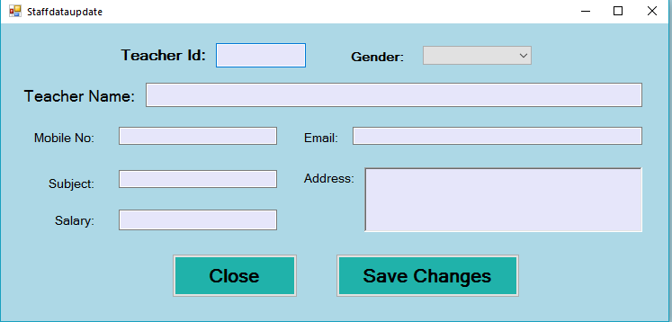

using System;

using System.Collections.Generic;

using System.ComponentModel;

using System.Data;

using System.Drawing;

using System.Linq;

using System.Text;

using System.Threading.Tasks;

using System.Windows.Forms;

using System.Data.OleDb;

namespace School_Management_Project

{

public partial class Staff_Update : Form

{

OleDbConnection con;

OleDbCommand cmd;

OleDbDataReader dr;

public Staff_Update()

{

InitializeComponent();

}

private void Staffdataupdate_Load(object sender, EventArgs e)

{

con = new OleDbConnection(@"Provider=Microsoft.ACE.OLEDB.12.0;Data Source=" + Application.StartupPath + "\\Database\\Schoolmanagementdata.accdb;Persist Security Info=False");

con.Open();

textBox2.Focus();

}

private void textBox2_TextChanged(object sender, EventArgs e)

{

cmd = new OleDbCommand("select * from Stafftable where Teacher_Id like '" + textBox2.Text + "'", con);

dr = cmd.ExecuteReader();

if (textBox2.Text == "")

{

comboBox1.SelectedIndex = -1;

textBox1.Clear();

textBox5.Clear();

textBox15.Clear();

textBox17.Clear();

textBox6.Clear();

richtxtaddress.Clear();

}

else if (dr.Read())

{

comboBox1.Text = dr.GetValue(2).ToString();

textBox1.Text = dr.GetValue(1).ToString();

textBox5.Text = dr.GetValue(3).ToString();

textBox15.Text = dr.GetValue(4).ToString();

textBox17.Text = dr.GetValue(5).ToString();

textBox6.Text = dr.GetValue(6).ToString();

richtxtaddress.Text = dr.GetValue(7).ToString();

}

else

{

comboBox1.SelectedIndex = -1;

textBox1.Clear();

textBox5.Clear();

textBox15.Clear();

textBox17.Clear();

textBox6.Clear();

richtxtaddress.Clear();

}

}

private void button2_Click(object sender, EventArgs e)

{

try

{

if (textBox2.Text == "")

{

MessageBox.Show("Plese Enter Teacher Id", "Blank Value", MessageBoxButtons.OK, MessageBoxIcon.Warning);

textBox2.Focus();

}

else

{

cmd = new OleDbCommand("update Stafftable set Teacher_Name='" + textBox1.Text + "',Gender='" + comboBox1.Text + "',Mobile_No='" + textBox5.Text + "',Email='" + textBox15.Text + "',Subject='" + textBox17.Text + "',Salary='" + textBox6.Text + "',Address='" + richtxtaddress.Text + "' where Teacher_Id=" + textBox2.Text + "", con);

int res = cmd.ExecuteNonQuery();

if (res > 0)

{

MessageBox.Show("Record Update Successfully", "Done", MessageBoxButtons.OK, MessageBoxIcon.Information);

this.Hide();

}

else

{

MessageBox.Show("Something Went Wrong", "Error", MessageBoxButtons.OK, MessageBoxIcon.Error);

}

}

}

catch (Exception ex)

{

MessageBox.Show(ex.Message, "Error", MessageBoxButtons.OK, MessageBoxIcon.Error);

}

}

private void button1_Click(object sender, EventArgs e)

{

this.Hide();

}

private void textBox5_KeyPress(object sender, KeyPressEventArgs e)

{

char ch = e.KeyChar;

if (!Char.IsDigit(ch) && ch != 8 && ch != 46)

{

e.Handled = true;

}

}

}

}

**Setting Portal**

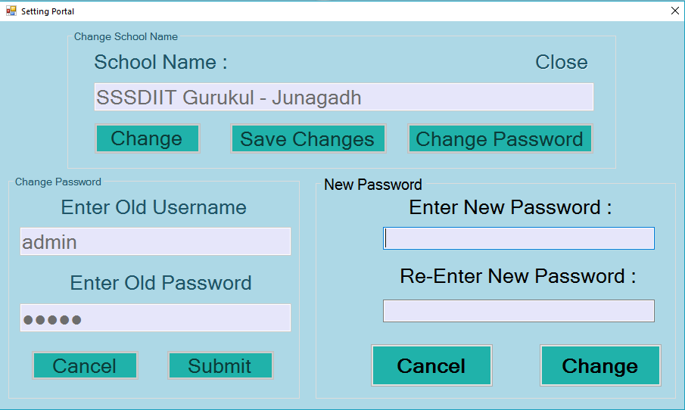

using System;

using System.Collections.Generic;

using System.ComponentModel;

using System.Data;

using System.Drawing;

using System.Linq;

using System.Text;

using System.Threading.Tasks;

using System.Windows.Forms;

using System.Data.OleDb;

namespace School_Management_Project

{

public partial class Settingportal : Form

{

OleDbConnection con;

OleDbCommand cmd;

OleDbDataReader dr;

public Settingportal()

{

InitializeComponent();

}

private void btnback_Click(object sender, EventArgs e)

{

Home h1 = new Home();

this.Hide();

h1.Show();

}

private void Settingportal_Load(object sender, EventArgs e)

{

con = new OleDbConnection(@"Provider=Microsoft.ACE.OLEDB.12.0;Data Source=" + Application.StartupPath + "\\Database\\Schoolmanagementdata.accdb;Persist Security Info=False");

con.Open();

txtschoolname.Enabled = false;

cmd = new OleDbCommand("select School_Name from SchoolName", con);

dr = cmd.ExecuteReader();

if (dr.Read())

{

txtschoolname.Text = dr.GetValue(0).ToString();

}

groupBox2.Hide();

btnsavechanges.Enabled = false;

groupBox3.Hide();

}

private void linkLabel1_LinkClicked(object sender, LinkLabelLinkClickedEventArgs e)

{

this.Close();

}

private void btnconfirmcancel_Click(object sender, EventArgs e)

{

txtolduser.Clear();

txtoldpass.Clear();

groupBox2.Hide();

groupBox1.Enabled = true;

}

private void btncange_Click(object sender, EventArgs e)

{

txtschoolname.Enabled = true;

btnsavechanges.Enabled = true;

btncange.Enabled = false;

txtschoolname.Focus();

}

private void btnsavechanges_Click(object sender, EventArgs e)

{

try

{

cmd = new OleDbCommand("update SchoolName set School_Name='" + txtschoolname.Text + "'", con);

cmd.ExecuteNonQuery();

MessageBox.Show("SchoolName Change Successfully, Please Refresh Your Software.", "Information", MessageBoxButtons.OK, MessageBoxIcon.Information);

txtschoolname.Enabled = false;

btncange.Enabled = true;

btnsavechanges.Enabled = false;

}

catch (Exception ex)

{

MessageBox.Show(ex.Message, "Error", MessageBoxButtons.OK, MessageBoxIcon.Error);

}

}

private void btnchangepass_Click(object sender, EventArgs e)

{

groupBox2.Show();

groupBox1.Enabled = false;

}

private void btnsubmit_Click(object sender, EventArgs e)

{

try

{

cmd = new OleDbCommand("select * from Login_Table", con);

dr = cmd.ExecuteReader();

dr.Read();

if (txtolduser.Text == ""||txtoldpass.Text=="")

{

MessageBox.Show("Please Enter Any Value.","Blank Value",MessageBoxButtons.OK,MessageBoxIcon.Warning);

if (txtolduser.Text == "")

txtolduser.Focus();

else

txtoldpass.Focus();

}

else if (txtolduser.Text == dr.GetValue(0).ToString() && txtoldpass.Text==dr.GetValue(1).ToString())

{

groupBox3.Show();

groupBox2.Enabled = false;

}

else

{

MessageBox.Show("Wrong Username OR Password.","Wrong",MessageBoxButtons.OK,MessageBoxIcon.Error);

txtolduser.Clear();

txtoldpass.Clear();

txtolduser.Focus();

}

}

catch (Exception ex)

{

MessageBox.Show(ex.Message, "Error", MessageBoxButtons.OK, MessageBoxIcon.Error);

}

}

private void btnchange_Click(object sender, EventArgs e)

{

try

{

if (txtnewpass.Text == ""||txtreenterpss.Text=="")

{

MessageBox.Show("Please Enter Any Value", "Blank Value", MessageBoxButtons.OK, MessageBoxIcon.Warning);

if (txtnewpass.Text == "")

txtnewpass.Focus();

else

txtreenterpss.Focus();

}

else if (txtnewpass.Text != txtreenterpss.Text)

{

MessageBox.Show("Both Password Are Not Same", "Not Equal", MessageBoxButtons.OK, MessageBoxIcon.Error);

txtnewpass.Clear();

txtreenterpss.Clear();

txtnewpass.Focus();

}

else

{

cmd = new OleDbCommand("update Login_Table set School_Password='" + txtnewpass.Text + "'", con);

int res=cmd.ExecuteNonQuery();

if (res > 0)

{

MessageBox.Show("Password Chaenged Successfully.", "Done", MessageBoxButtons.OK, MessageBoxIcon.Information);

txtnewpass.Clear();

txtreenterpss.Clear();

groupBox2.Hide();

groupBox3.Hide();

groupBox2.Enabled = true;

txtolduser.Clear();

txtoldpass.Clear();

groupBox1.Enabled = true;

}

else

{

MessageBox.Show("Something Went Wrong");

}

}

}

catch (Exception ex)

{

MessageBox.Show(ex.Message, "Error", MessageBoxButtons.OK, MessageBoxIcon.Error);

}

}

private void btncalcel_Click(object sender, EventArgs e)

{

txtnewpass.Clear();

txtreenterpss.Clear();

groupBox2.Hide();

groupBox3.Hide();

groupBox2.Enabled = true;

txtolduser.Clear();

txtoldpass.Clear();

groupBox1.Enabled = true;

}

}

}

**About Us**

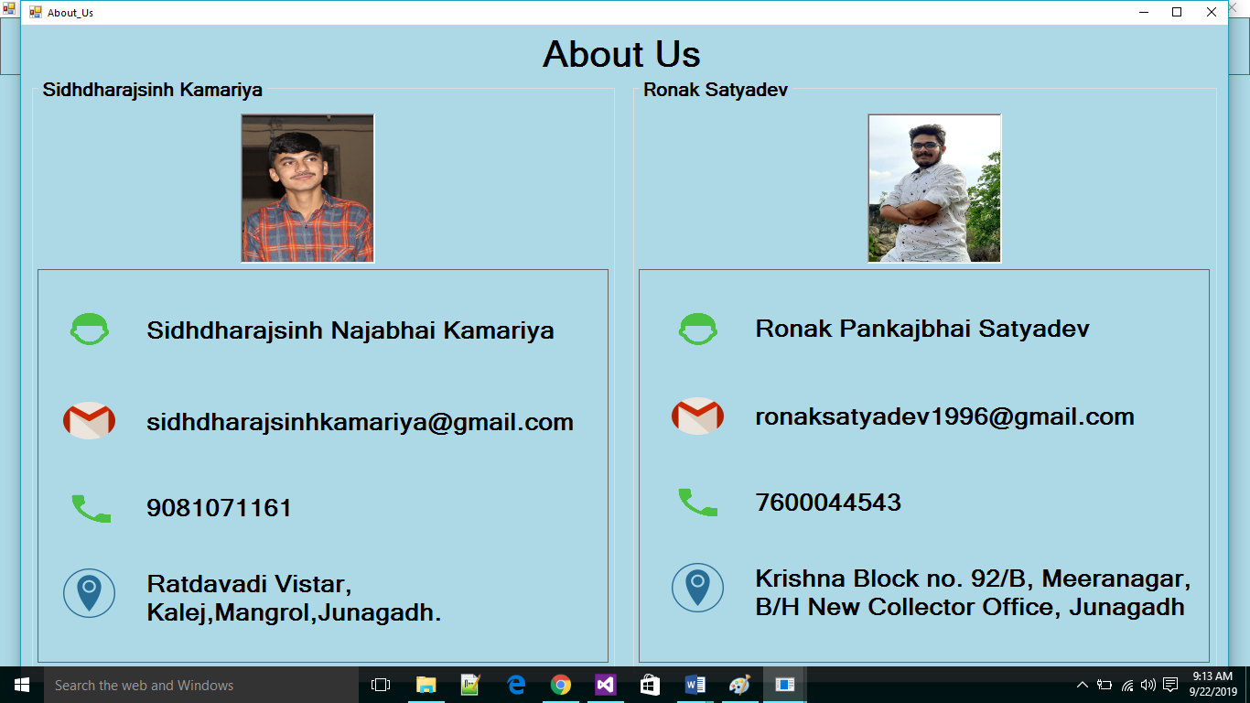

* **Informatin About Us.**

**Biblography**

**• References:**

**1) Web developing using C#.net**

Authors : Mayank Mankodi & group.

Publication: Bharat & com.

C#.NET Black Book

**Websites:**

**1. www.connectionstring.com**

**2. www.codeguru.com**

**3. www.codeproject.com**

**4. www.stackoverflow.com**

**5. www.ehow.com**

**6.** [**www.google.co.in**](http://www.google.co.in)

**7.www.w3school.com**